A strategy game for two players aged 12 and up, lasting about 20 minutes.
Compete to capture artefacts on an alien world. You and your opponent share a system of orbital satellites, whose charges rise and fall as they’re used. Each satellite lets you use your bots to capture artefacts and tanks to destroy enemy units.
On your turn, choose a satellite and carry out its action once per charge upon it. Then spread its charges on to neighbouring satellites, determining your opponent’s options – don’t hand your opponent the means to defeat you.

Components
1 board, 8 charge counters, 20 double-sided units (tank/bot) in each colour, 6 artefacts, 6 satellites, 2 10-sided score dice.

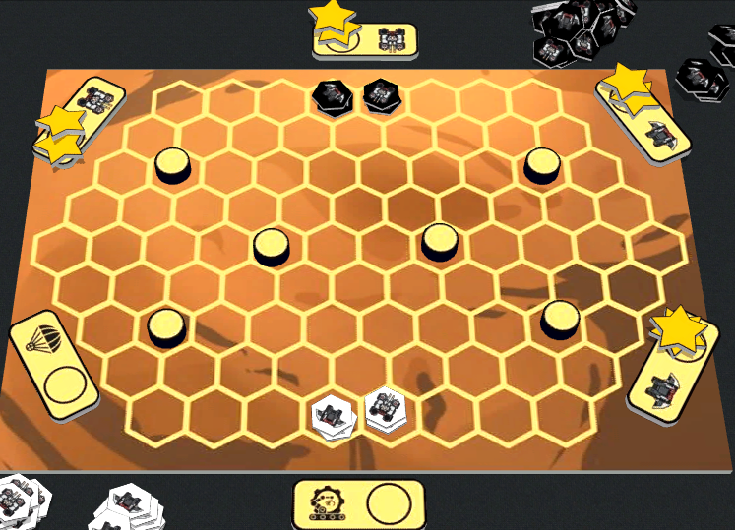
Set up
Place the six satellites around the board at random.
Place two charges on each Tank 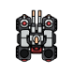 and Bot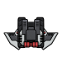 satellite. Drop Tank  and Build Bot  start with none.
Place an artefact on the six spaces shown.
Take the units of your chosen colour. Each player places:
Two bots
and two tanks
on the spaces shown (8 units on the board altogether, each type opposite its matching enemy)
Give each player a score die, set to 0.
Choose a starting player.
Units are double sided. Place them with the needed side up.

Turn Structure
Take alternating turns. On your turn Choose -> Activate -> Spread.

1: choose
Choose a satellite and pick up its charges.

2: Activate
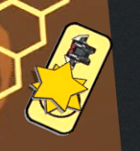
For each charge, you may carry out that satellite’s action once.
Matilda chooses a Bot satellite. She performs up to 2 Bot actions.

3: Spread
Choose clockwise or counterclockwise. Place one charge on to the next satellite in that direction, another on to the one after that, and so on, until you run out.

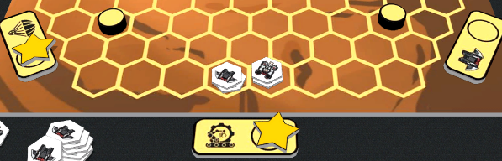
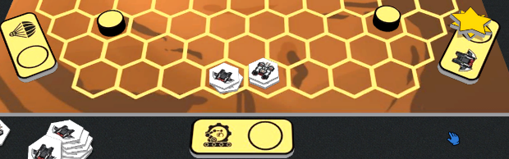

Matilda chooses clockwise, so she moves 1 charge on to Build Bot and the other on to Drop Tank.

The Actions

Drop Tank
Place a tank from your supply on to either:
If your supply is empty when you need a unit, first return one from the board to your supply.
- an empty space or
- a space containing one or more of your tanks.
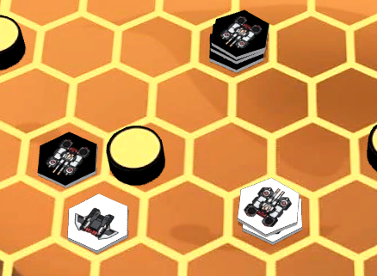
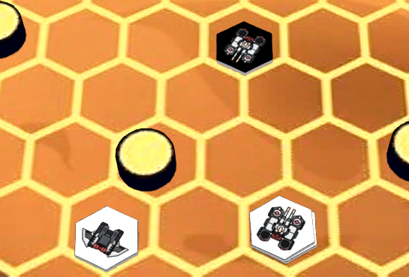
You can’t place on to your opponent’s starting spaces.

She drops 2 on to a existing tank and 1 on to an empty space.

Matilda (black) has 3 Drop Tank charges.

BUILD Bot
Place a bot from your supply on to:
- a space containing one or more of your bots or
- one of your starting spaces if it’s empty.
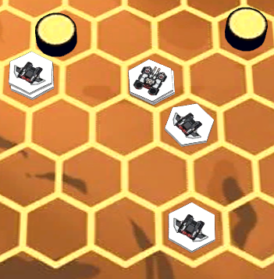
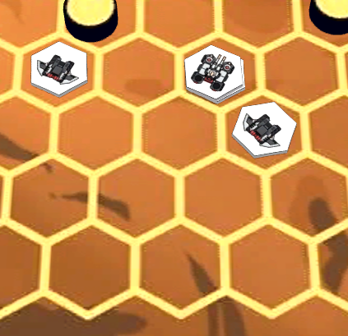

He builds 1 on an existing bot and another on one of his empty starting spaces.
Lev has 2 Build Bot charges.

Bot
Move any number of your bots from a single space to the an adjacent one that’s empty or contains one or more of your bots. (You may leave bots behind, and merge with others. They must all move to the same space) You can’t move into your opponent's starting spaces.
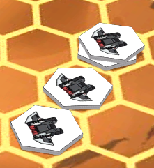
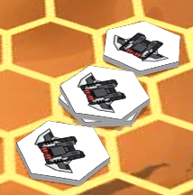
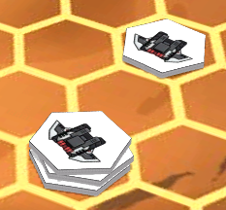

Then the second charge to move 1 of those 2 on to another bot.
He spends 1 to move 2 bots from a stack of 3 one space.
Lev has 2 Bot charges.

Capturing artefacts
Bots can also move on to artefacts. Return the artefact to the box. Earn one point per bot in the capturing stack. Track your score with your die.
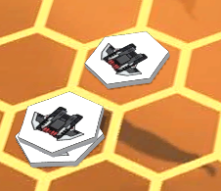
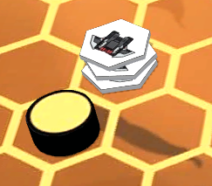

He captures it with two bots, earning two points.
Lev’s bots approach an artefact.

Tank
Either Move or Shoot.

Move
Move any number of your tanks from a single space to an adjacent one that’s empty or contains one or more of your tanks. (You may leave tanks behind, and merge with others.) You can’t move on to your opponent's starting spaces. See bot example above.

Shoot
Choose a single space containing one or more of your tanks. Choose an adjacent space for these tanks to shoot into. You can’t shoot into your opponent's starting spaces.
- If the target space contains enemy bots, destroy them all.
- If it contains enemy tanks, destroy them all unless they outnumber you. (You can only destroy tank stacks of the same size or smaller).
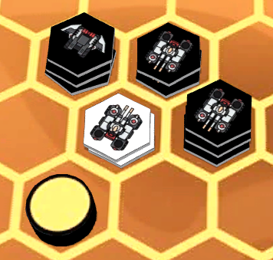
Return destroyed units to their owner’s supply.

If Lev spent a Tank charge to make his stack of 2 tanks shoot, he could destroy all the bots or the stack of 2 tanks. He could not destroy the stack of 3 tanks.

Victory

- When you have 9 or more points, you win.
- When the last artefact is captured, whoever has more points wins.
  - If tied, the player whose turn it is wins.
Any questions to NeilCCrowley@gmail.com

